FILE 1 – EXECUTION TIME, MEMORY USAGE & OPERATION COUNTS
LAB 2 – Algorithm Performance Measurement and Benchmarking Tool
Design and Analysis of Algorithms Laboratory

Student Name | Yashvi Sahu
Roll No. | 2401201010
Course / Semester | BCA / 5th
Subject | Design and Analysis of Algorithms

Question 2 – Search Algorithm Analysis
This section records Linear Search and Binary Search performance for input sizes 100, 1,000, 10,000 and 50,000. The screenshots are the user's original notebook code and outputs.
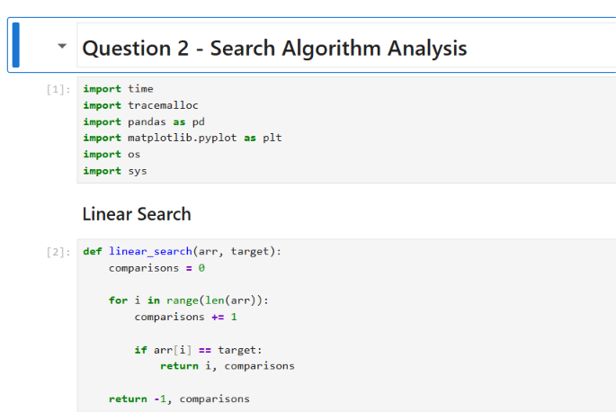
Q2 – Linear Search implementation
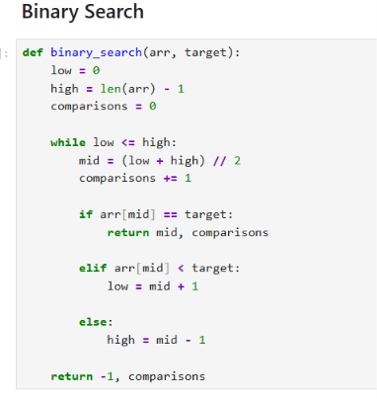
Q2 – Binary Search implementation
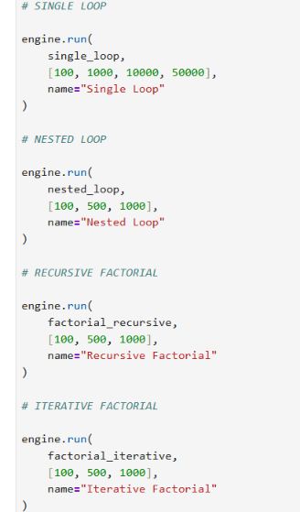
Q2 – Dataset generation and search-performance measurement
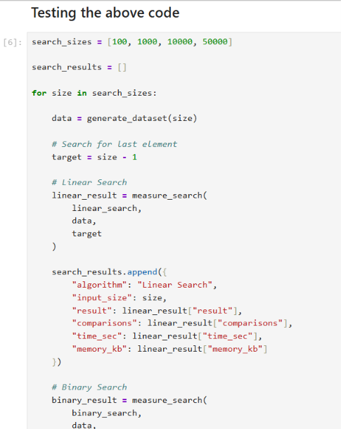
Q2 – Testing the search algorithms for multiple input sizes
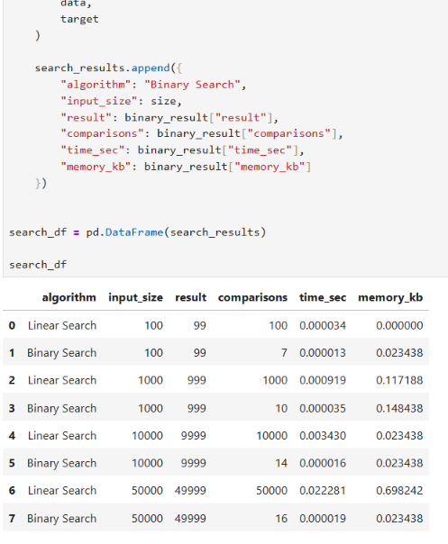
Q2 – Search results with comparisons, execution time and memory

Question 3 – Code Benchmarking Module
The module benchmarks Single Loop, Nested Loop, Recursive Factorial and Iterative Factorial using execution time, peak memory and operation counts.
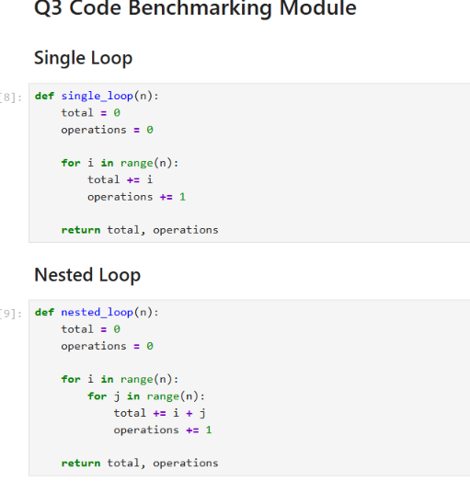
Q3 – Single Loop and Nested Loop
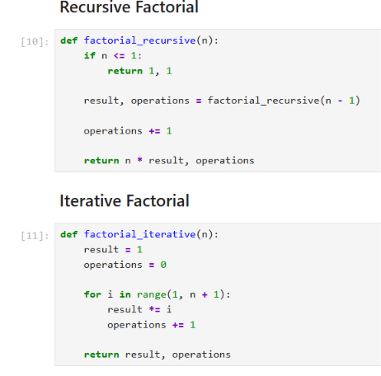
Q3 – Recursive and Iterative Factorial
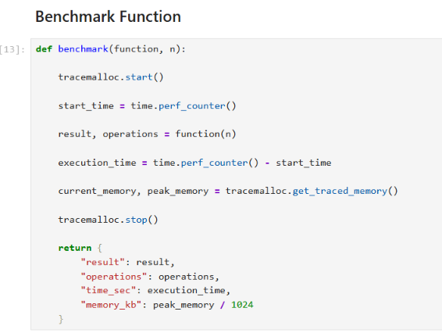
Q3 – Benchmark function
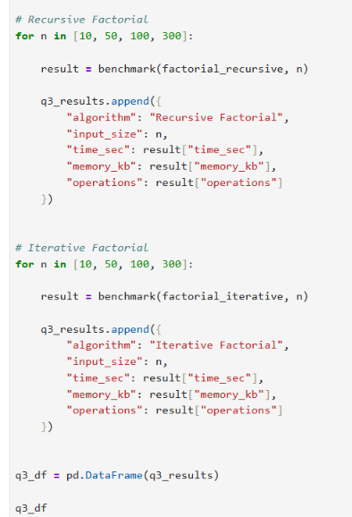
Q3 – Testing the benchmarking code
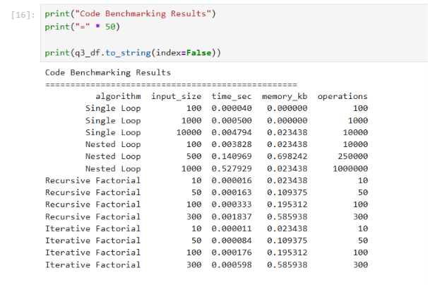
Q3 – Printed benchmarking results
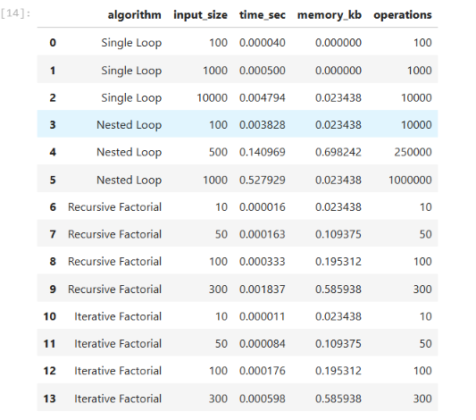
Q3 – Benchmarking results table

Question 4 – Automated Benchmarking Engine
The BenchmarkEngine automates repeated benchmarking over multiple input sizes and stores the results in a pandas DataFrame and CSV file.
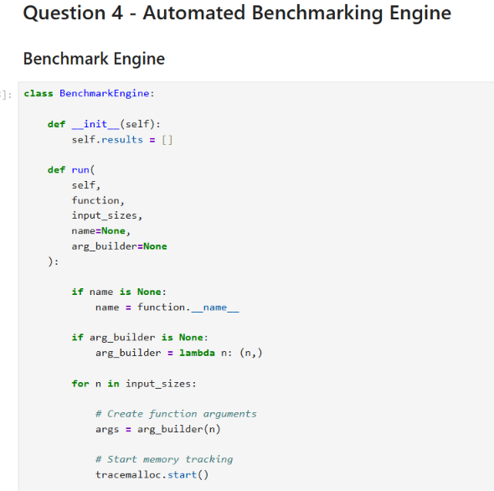
Q4 – BenchmarkEngine implementation, part 1
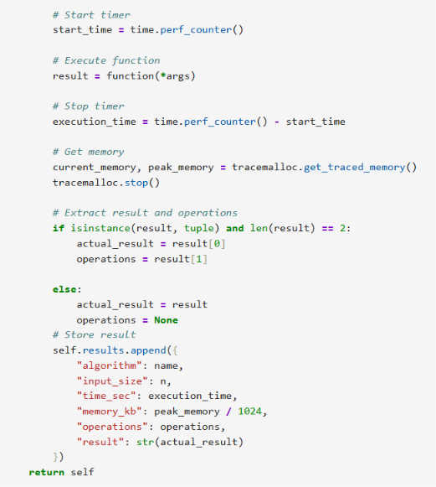
Q4 – BenchmarkEngine implementation, part 2
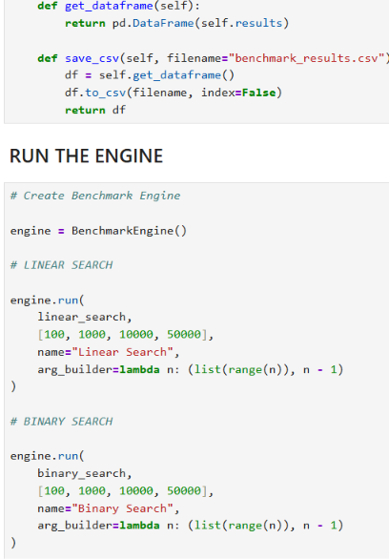
Q4 – Running the automated benchmarking engine
Q4 – Engine execution setup
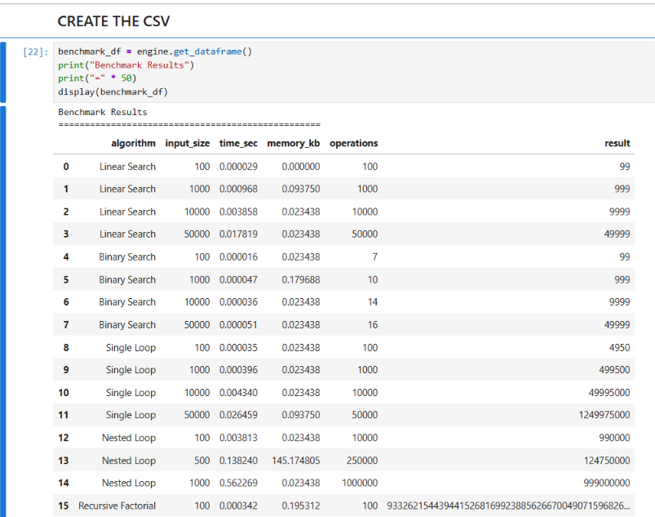
Q4 – Generated benchmark results
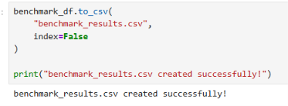
Q4 – benchmark_results.csv created successfully

https://github.com/YashviSahu555/DAA-Lab-File-2

